Task 8.1.5

Query 1: UPDATE Purchase SET shipDate = '2018-05-19' WHERE purchaseID = 111;



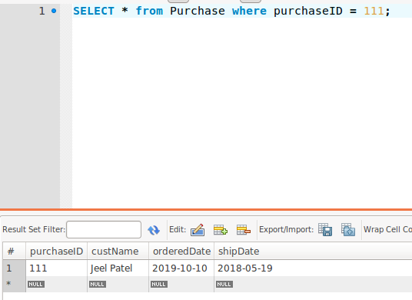

Query 2: UPDATE Purchase SET shipDate = ‘2019-01-13’, orderedDate = ‘2019-01-03’ WHERE purchaseID = 111;



